**Changing Skybox During Menus**

Within menu screen:

Players will be able to swipe up and down to go back and forth between different skyboxes.

The image will slide either up or down. Depending on the swipe direction.

A player will not be locked to a specific skybox until they have begun playing.

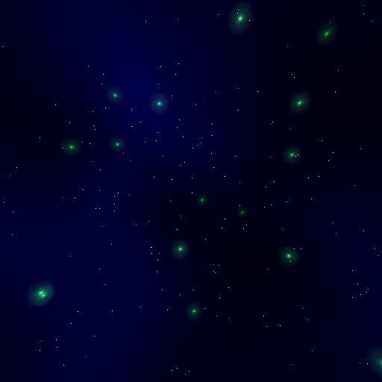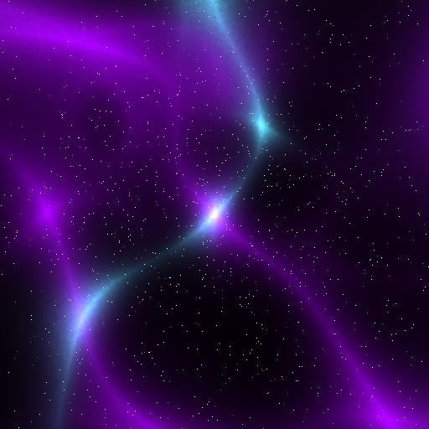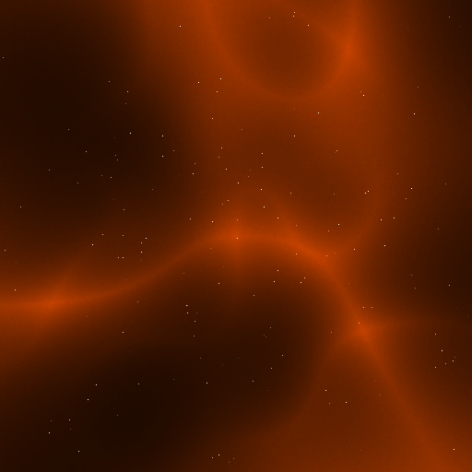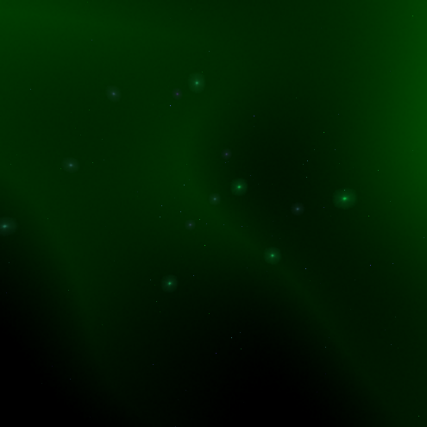Once playing the player will not be able to change his in-game background for that planet. (Maybe allow the player to change the menu screen skybox though…?)